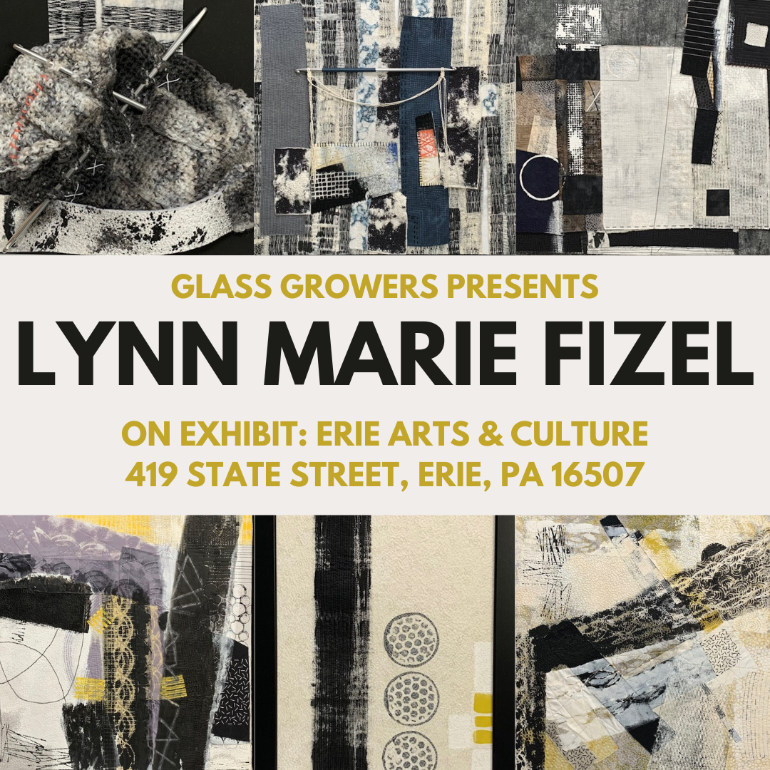

PRESS RELEASE:   
**NEW GLASS GROWERS EXHIBIT AT ERIE ARTS & CULTURE: LYNN MARIE FIZEL**

FOR IMMEDIATE RELEASE

**Glass Growers Presents: *Lynn Marie Fizel’s Fiber Art at Erie Arts & Culture***

**Exhibition Dates:** Now – September, 2025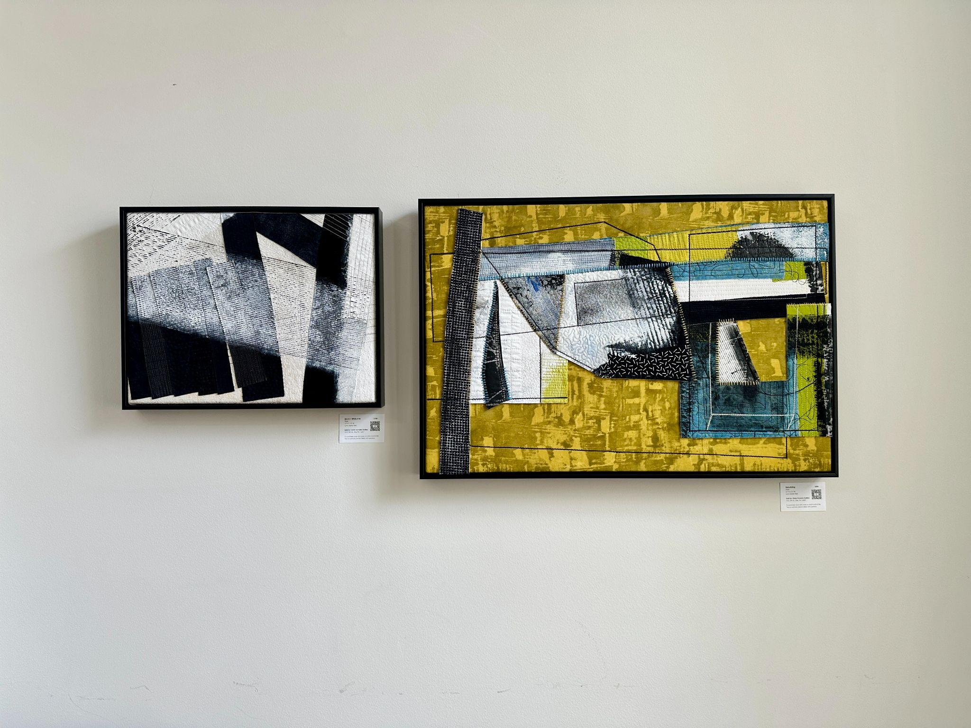

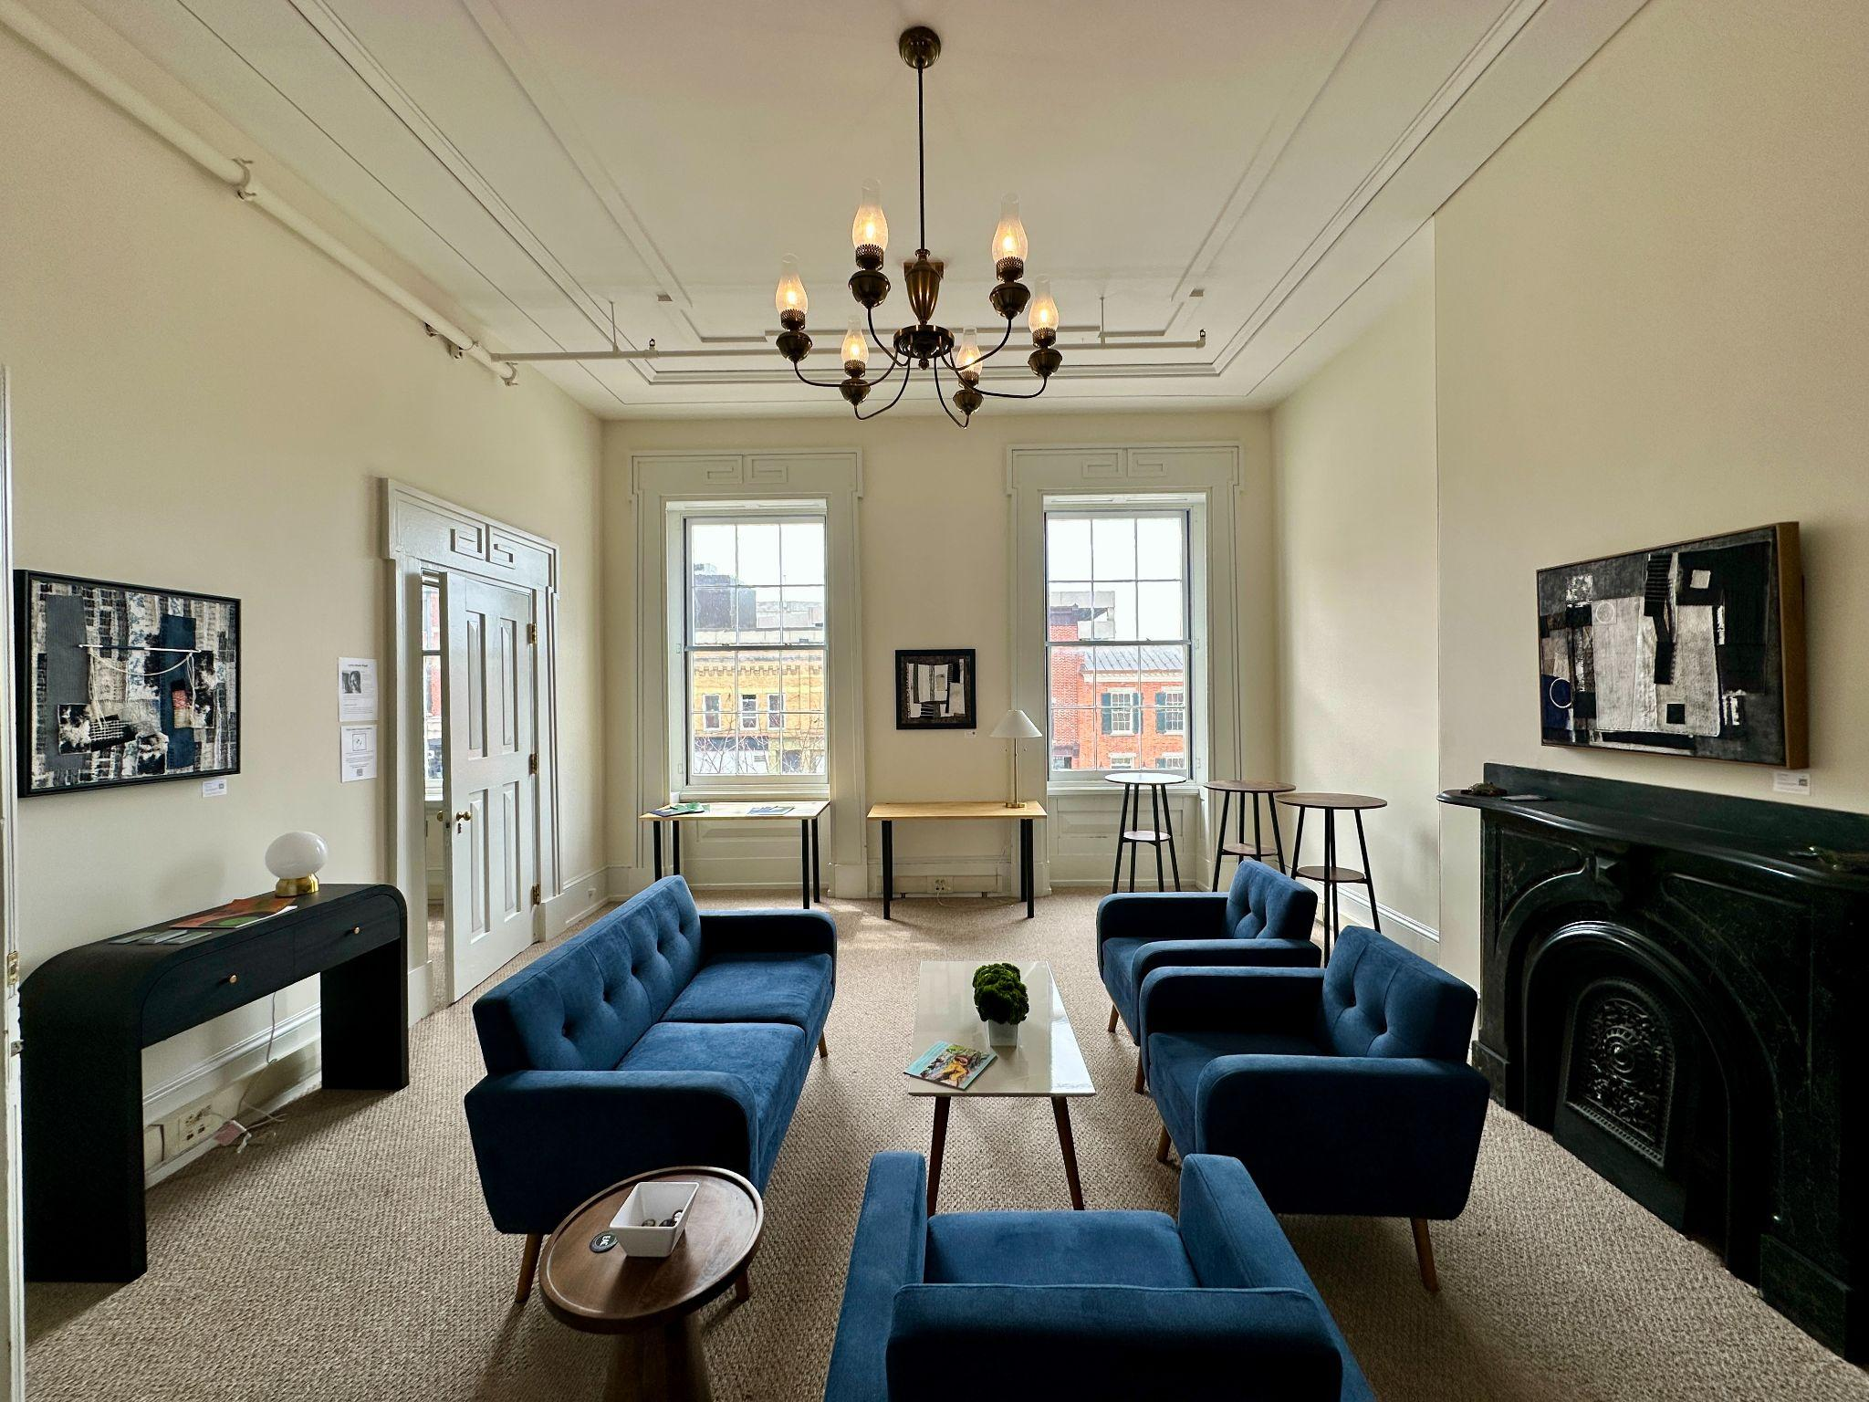

Any questions/requests can be directed to Glass Growers owner Emily Ernes:   
[emily@glassgrowersgallery.com](mailto:emily@glassgrowersgallery.com)  
440-812-8862

**Artist Statement:**

About Works in Conference Room:

“The layering of fabric, thread and paint is the hallmark of my work. Color, shape, and especially texture,

invite the viewer to immerse themselves in a playful, unconventional and unique perspective.” - Lynn Marie Fizel

About Works in Lounge:   
“Wabi-Sabi is a Japanese philosophy and aesthetic that embraces the beauty of impermanence, imperfection, loss and brokenness, with a nod to the art of repair and healing. With that in mind, I created these works from reimagined fabric pieces that were combined and then sewn, glued and/or stitched together.” - Lynn Marie Fizel

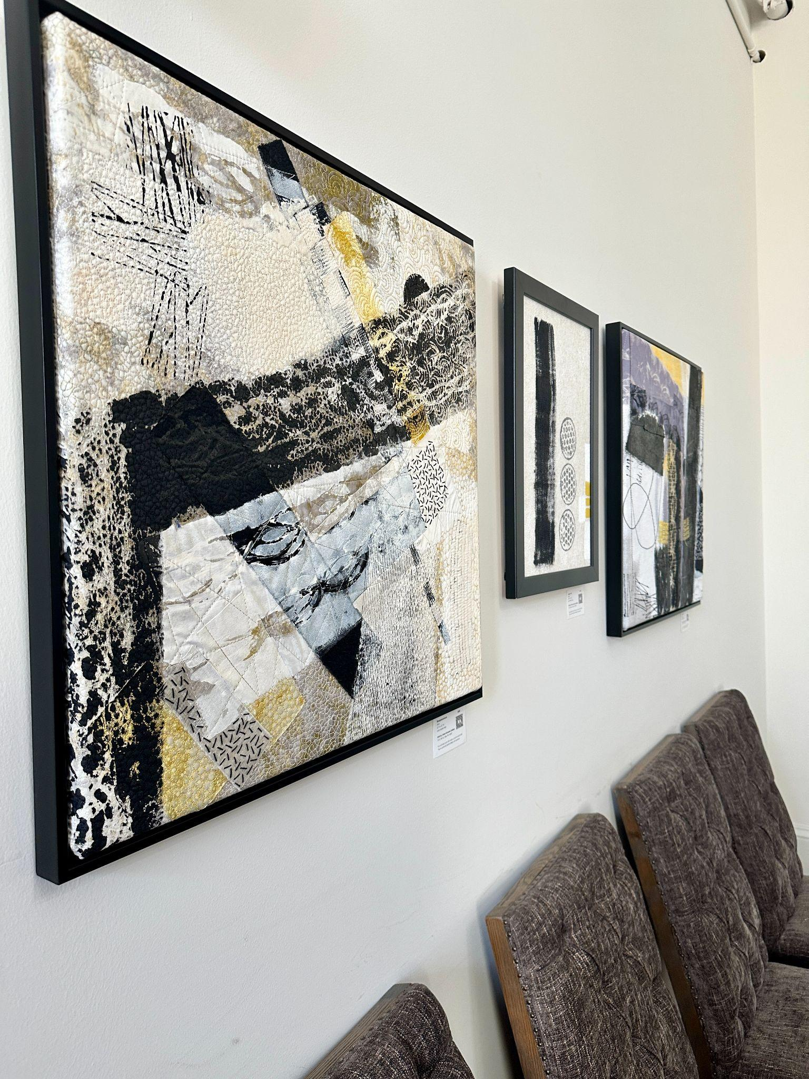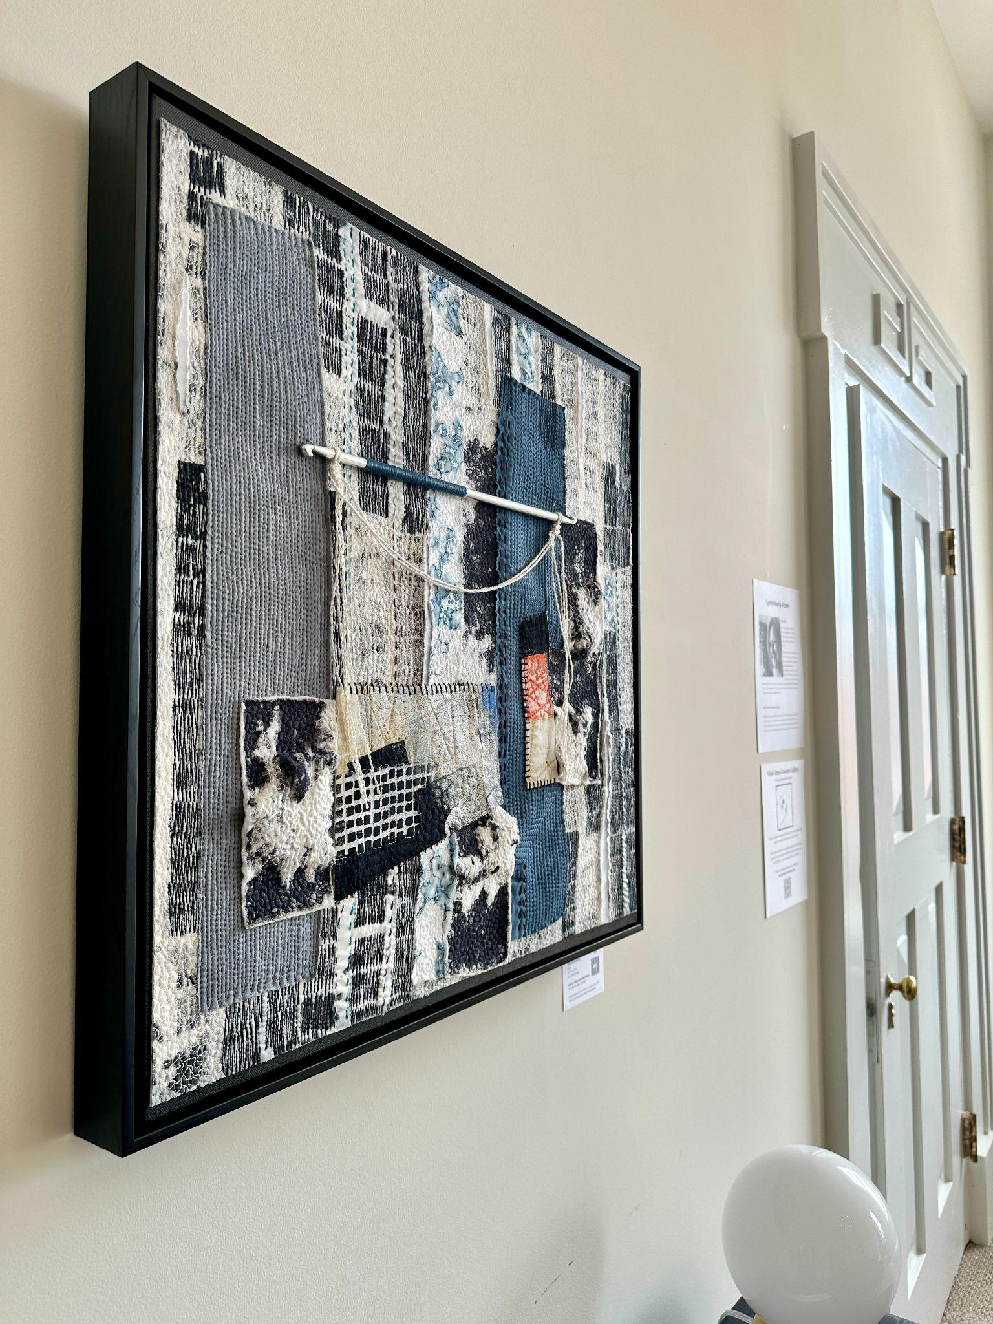

**Artist Bio:**

“I am a fiber artist residing in Erie, Pennsylvania. My work is mostly abstract, created with layers of fabric, thread and paint.”

“My art is rooted in process; the experimental, non-linear way in which I create takes precedence over any predetermined composition. In turn, the means by which I make art is rooted in self discovery and expression. I cannot say that I value process over product; I am just mindful that honoring my voice is why I do what I do. My hope is that my work will inspire the viewer to tap into their own unique perspective.” -Lynn Marie Fizel